C practicum les 4
Semester NSE 4
Voor alle opdrachten geldt: 100% C code

Opgave 1:
- Maak een simpele socket server applicatie (met WinSock) die een antwoord geeft op een verzoek van een client.
- Maak ook de client applicatie en test deze samen met de server. Alles draait op 1 PC. Visual Studio kan je meerdere keren open hebben staan zodat je zowel de client als de server tegelijkertijd in in Visual Studio runnen. Je kan nu ook breakpoints zetten ivm debuggen.
- Laat zien dat je ook met blocking recv prima meerdere clients en 1 server kan hebben. Iedere client krijg op zijn verzoek een keurig antwoord. Multithreading is ook niet nodig voor dit resultaat
- Voor een machine-2-machine communicatie is een key-value bericht handiger dan vrije tekst. Dit geldt ook voor het antwoord. Laat zien dat op deze manier de temperatuur of luchtvochtigheid kan doorgeven. Als antwoord kan je terug krijgen op welke snelheid een ventilator moet draaien. NB: JSON is nog krachtiger maar lastiger. JSON wordt niet via een standaard library en/of functies ondersteunt maar via https://github.com/DaveGamble/cJSON Als je cJSON.h en cJSON.c include in je project kan je met JSON werken.
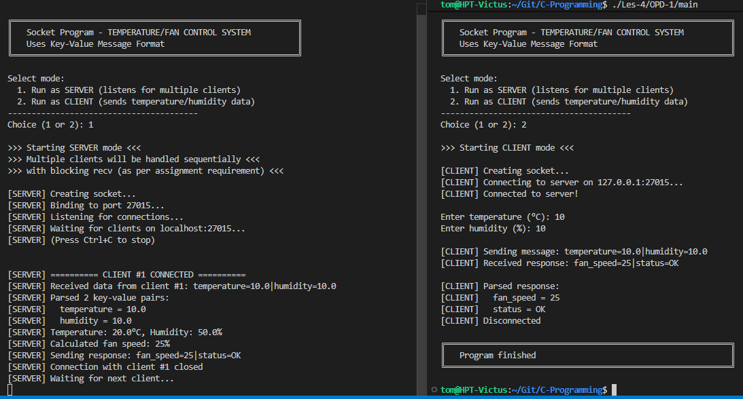
Figure 1 Socket Over Network
#include <stdio.h>
#include <stdlib.h>
#include <string.h>
#include <unistd.h>
#include <sys/socket.h>
#include <netinet/in.h>
#include <arpa/inet.h>
#include <errno.h>

#define SERVER_IP "127.0.0.1"
#define PORT 27015
#define BUFSIZE 512

// ============ Key-Value Message Parsing ============

typedef struct {
char key[64];
char value[64];
} KeyValue;

typedef struct {
KeyValue pairs[10];
int count;
} Message;

// Parse "key1=value1|key2=value2" format
Message parse_message(const char* msg) {
Message result = {0};
char temp[BUFSIZE];
strncpy(temp, msg, sizeof(temp) - 1);
temp[sizeof(temp) - 1] = '\0';

char* pair = strtok(temp, "|");
while (pair && result.count < 10) {
char* eq = strchr(pair, '=');
if (eq) {
int key_len = eq - pair;
strncpy(result.pairs[result.count].key, pair, key_len);
result.pairs[result.count].key[key_len] = '\0';
strcpy(result.pairs[result.count].value, eq + 1);
result.count++;
}
pair = strtok(NULL, "|");
}
return result;
}

// Create "key1=value1|key2=value2" format
void create_message(char* buffer, int size, const char** keys, const char** values, int count) {
buffer[0] = '\0';
for (int i = 0; i < count; i++) {
if (i > 0) strcat(buffer, "|");
strcat(buffer, keys[i]);
strcat(buffer, "=");
strcat(buffer, values[i]);
}
}

// Get value by key
const char* get_value(Message msg, const char* key) {
for (int i = 0; i < msg.count; i++) {
if (strcmp(msg.pairs[i].key, key) == 0) {
return msg.pairs[i].value;
}
}
return NULL;
}

// ============ Server Function ============

void run_server(void) {
int listenSock, clientSock;
struct sockaddr_in serverAddr;
char buf[BUFSIZE];
char response[BUFSIZE];
int received;
int client_count = 0;

printf("[SERVER] Creating socket...\n");
listenSock = socket(AF_INET, SOCK_STREAM, IPPROTO_TCP);
if (listenSock < 0) {
printf("[SERVER] Error: socket failed: %s\n", strerror(errno));
return;
}

// Set socket option to reuse address
int reuse = 1;
setsockopt(listenSock, SOL_SOCKET, SO_REUSEADDR, &reuse, sizeof(reuse));

memset(&serverAddr, 0, sizeof(serverAddr));
serverAddr.sin_family = AF_INET;
serverAddr.sin_addr.s_addr = INADDR_ANY;
serverAddr.sin_port = htons(PORT);

printf("[SERVER] Binding to port %d...\n", PORT);
if (bind(listenSock, (struct sockaddr*)&serverAddr, sizeof(serverAddr)) < 0) {
printf("[SERVER] Error: bind failed: %s\n", strerror(errno));
close(listenSock);
return;
}

printf("[SERVER] Listening for connections...\n");
if (listen(listenSock, 5) < 0) {
printf("[SERVER] Error: listen failed: %s\n", strerror(errno));
close(listenSock);
return;
}

printf("[SERVER] Waiting for clients on localhost:%d...\n", PORT);
printf("[SERVER] (Press Ctrl+C to stop)\n\n");

// Accept multiple clients (blocking recv handles one at a time sequentially)
while (1) {
clientSock = accept(listenSock, NULL, NULL);
if (clientSock < 0) {
printf("[SERVER] Error: accept failed: %s\n", strerror(errno));
continue;
}

client_count++;
printf("\n[SERVER] ========== CLIENT #%d CONNECTED ==========\n", client_count);

// Receive message from client
received = recv(clientSock, buf, BUFSIZE - 1, 0);
if (received > 0) {
buf[received] = '\0';
printf("[SERVER] Received data from client #%d: %s\n", client_count, buf);

// Parse key-value message
Message msg = parse_message(buf);
printf("[SERVER] Parsed %d key-value pairs:\n", msg.count);
for (int i = 0; i < msg.count; i++) {
printf("[SERVER] %s = %s\n", msg.pairs[i].key, msg.pairs[i].value);
}

// Get temperature and humidity values
const char* temp_str = get_value(msg, "temperature");
const char* humidity_str = get_value(msg, "humidity");

float temperature = 20.0f;
float humidity = 50.0f;
int fan_speed = 25;

if (temp_str) {
temperature = atof(temp_str);
}
if (humidity_str) {
humidity = atof(humidity_str);
}

// Calculate fan speed based on temperature
if (temperature > 30.0f) {
fan_speed = 100;
} else if (temperature > 25.0f) {
fan_speed = 75;
} else if (temperature > 20.0f) {
fan_speed = 50;
} else {
fan_speed = 25;
}

printf("[SERVER] Temperature: %.1f°C, Humidity: %.1f%%\n", temperature, humidity);
printf("[SERVER] Calculated fan speed: %d%%\n", fan_speed);

// Create response message
char fan_speed_str[16];
sprintf(fan_speed_str, "%d", fan_speed);
const char* resp_keys[] = {"fan_speed", "status"};
const char* resp_values[] = {fan_speed_str, "OK"};
create_message(response, sizeof(response), resp_keys, resp_values, 2);

printf("[SERVER] Sending response: %s\n", response);
send(clientSock, response, strlen(response), 0);
}

close(clientSock);
printf("[SERVER] Connection with client #%d closed\n", client_count);
printf("[SERVER] Waiting for next client...\n");
}

close(listenSock);
}

// ============ Client Function ============

void run_client(void) {
int sock;
struct sockaddr_in serverAddr;
char buf[BUFSIZE];
char message[BUFSIZE];
int received;
float temperature, humidity;

printf("[CLIENT] Creating socket...\n");
sock = socket(AF_INET, SOCK_STREAM, IPPROTO_TCP);
if (sock < 0) {
printf("[CLIENT] Error: socket failed: %s\n", strerror(errno));
return;
}

memset(&serverAddr, 0, sizeof(serverAddr));
serverAddr.sin_family = AF_INET;
serverAddr.sin_port = htons(PORT);
inet_pton(AF_INET, SERVER_IP, &serverAddr.sin_addr);

printf("[CLIENT] Connecting to server on %s:%d...\n", SERVER_IP, PORT);
if (connect(sock, (struct sockaddr*)&serverAddr, sizeof(serverAddr)) < 0) {
printf("[CLIENT] Error: connect failed: %s\n", strerror(errno));
close(sock);
return;
}

printf("[CLIENT] Connected to server!\n\n");

// Get temperature and humidity from user
printf("Enter temperature (°C): ");
scanf("%f", &temperature);
printf("Enter humidity (%%): ");
scanf("%f", &humidity);

// Create key-value message
char temp_str[32], humidity_str[32];
sprintf(temp_str, "%.1f", temperature);
sprintf(humidity_str, "%.1f", humidity);
const char* keys[] = {"temperature", "humidity"};
const char* values[] = {temp_str, humidity_str};
create_message(message, sizeof(message), keys, values, 2);

printf("\n[CLIENT] Sending message: %s\n", message);
send(sock, message, strlen(message), 0);

// Receive response
received = recv(sock, buf, BUFSIZE - 1, 0);
if (received > 0) {
buf[received] = '\0';
printf("[CLIENT] Received response: %s\n\n", buf);

// Parse response
Message response = parse_message(buf);
printf("[CLIENT] Parsed response:\n");
for (int i = 0; i < response.count; i++) {
printf("[CLIENT] %s = %s\n", response.pairs[i].key, response.pairs[i].value);
}

const char* fan_speed_str = get_value(response, "fan_speed");
if (fan_speed_str) {
printf("\n[CLIENT] Server recommends fan speed: %s%%\n", fan_speed_str);
}
}

close(sock);
printf("[CLIENT] Disconnected\n");
}

// ============ Main Menu ============

int main(void) {
int choice;

printf("\n");
printf("╔════════════════════════════════════════════════════════════╗\n");
printf("║ Socket Program - TEMPERATURE/FAN CONTROL SYSTEM ║\n");
printf("║ Uses Key-Value Message Format ║\n");
printf("╚════════════════════════════════════════════════════════════╝\n");
printf("\n");
printf("Select mode:\n");
printf(" 1. Run as SERVER (listens for multiple clients)\n");
printf(" 2. Run as CLIENT (sends temperature/humidity data)\n");
printf("----------------------------------------\n");
printf("Choice (1 or 2): ");
scanf("%d", &choice);
printf("\n");

switch (choice) {
case 1:
printf(">>> Starting SERVER mode <<<\n");
printf(">>> Multiple clients will be handled sequentially <<<\n");
printf(">>> with blocking recv (as per assignment requirement) <<<\n\n");
run_server();
break;
case 2:
printf(">>> Starting CLIENT mode <<<\n\n");
run_client();
break;
default:
printf("Invalid choice. Please enter 1 or 2.\n");
return 1;
}

printf("\n╔════════════════════════════════════════════════════════════╗\n");
printf("║ Program finished ║\n");
printf("╚════════════════════════════════════════════════════════════╝\n\n");

return 0;
}

Ja ik heb de Code Wat complexer gemaakt dan nodig maar ik wilde kijken of ik met een file een server of client kon zijn :)

Opgave 2: Meerdere computers
- Laat op je eigen PC (of lap PC) zien wat er moet gebeuren als je een server laat draaien waarbij een client op een andere machine een request maakt naar deze server.
Zie Figuur 1 :) dat waren 2 machines, gewoon de Server_IP varible veranderen en Recompilen
- Moet er ook nog wat gebeuren op de machine van de client?
Ja Deze moet een Request Sturen naar de Server
- Kan je met telnet of curl op een Linux machine een request maken naar de server? En welke data wordt er dan verstuurd?
PS C:\Users\Tom> curl ifconfig.me
StatusCode : 200
StatusDescription : OK
Content : <!DOCTYPE html>
<html lang="en">
<head>
<meta http-equiv="Content-Type" content="text/html; charset=UTF-8">
<meta http-equiv="content-style-type" content="text/css" />
<meta http-equiv="c...
RawContent : HTTP/1.1 200 OK
access-control-allow-origin: *
Content-Length: 10662
Content-Type: text/html; charset=utf-8
Date: Tue, 17 Mar 2026 14:47:22 GMT
Via: 1.1 google

<!DOCTYPE html>
<html lang="en">...
Forms : {}
Headers : {[access-control-allow-origin, *], [Content-Length, 10662], [Content-Type, text/html; charset=utf-8], [Date, Tue, 17 Mar 2026 14:47:22 GMT]...}
Images : {}
InputFields : {}
Links : {@{innerHTML=IPinfo.io; innerText=IPinfo.io; outerHTML=<A href="https://ipinfo.io/?utm_source=ifconfig.me&amp;utm_medium=referral&amp;utm_campaign=upsell_sister_sites">IPinfo.io</A>;
outerText=IPinfo.io; tagName=A; href=https://ipinfo.io/?utm_source=ifconfig.me&amp;utm_medium=referral&amp;utm_campaign=upsell_sister_sites}, @{innerHTML=What Is My IP Address? -
ifconfig.me; innerText=What Is My IP Address? - ifconfig.me; outerHTML=<A href="http://ifconfig.me">What Is My IP Address? - ifconfig.me</A>; outerText=What Is My IP Address? -
ifconfig.me; tagName=A; href=http://ifconfig.me}, @{innerHTML=; innerText=; outerHTML=<A class=twitter-share-button href="http://twitter.com/share" data-count="horizontal" data-text="What
Is My IP Address? - ifconfig.me" data-url="http://ifconfig.me/"></A>; outerText=; tagName=A; class=twitter-share-button; href=http://twitter.com/share; data-count=horizontal;
data-text=What Is My IP Address? - ifconfig.me; data-url=http://ifconfig.me/}}
ParsedHtml : System.__ComObject
RawContentLength : 10662
PS C:\Users\Tom>
Super handig website om je ip te vinden en in Terminal in linux met Curl krijg je aleen je Public ip terug(handig voor Scripts)

- Maak via je eigen client (C programma) een request naar een webserver op het internet. Je maakt dus een simpel http request. Wat is de response van de webserver? En welk deel geeft aan of het een correct request is en welke andere delen bevat de response? Een korte uitleg van het http 1.1 protocol vind je oa hier: https://developer.mozilla.org/en-US/docs/Web/HTTP/Overview#http_flow

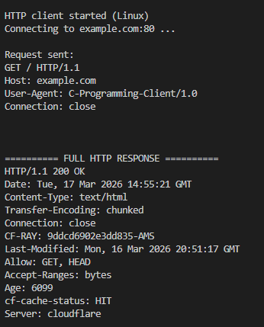
#define _POSIX_C_SOURCE 200112L

#include <stdio.h>
#include <stdlib.h>
#include <string.h>
#include <unistd.h>
#include <sys/types.h>
#include <sys/socket.h>
#include <netdb.h>
#include <errno.h>

#define HOST "example.com"
#define PORT "80"
#define PATH "/"
#define BUFFER_SIZE 1024
#define RESPONSE_SIZE 65536

static int connect_to_server(const char *host, const char *port) {
struct addrinfo hints;
struct addrinfo *result;
struct addrinfo *rp;
int sockfd;
int status;

memset(&hints, 0, sizeof(hints));
hints.ai_family = AF_UNSPEC;
hints.ai_socktype = SOCK_STREAM;

status = getaddrinfo(host, port, &hints, &result);
if (status != 0) {
printf("getaddrinfo failed: %s\n", gai_strerror(status));
return -1;
}

sockfd = -1;
for (rp = result; rp != NULL; rp = rp->ai_next) {
sockfd = socket(rp->ai_family, rp->ai_socktype, rp->ai_protocol);
if (sockfd == -1) {
continue;
}

if (connect(sockfd, rp->ai_addr, rp->ai_addrlen) == 0) {
break;
}

close(sockfd);
sockfd = -1;
}

freeaddrinfo(result);
return sockfd;
}

int main(void) {
int sockfd;
char request[512];
char buffer[BUFFER_SIZE];
char response[RESPONSE_SIZE];
int total_received;
ssize_t sent_bytes;
ssize_t received_bytes;
char *header_end;
char *line_end;

printf("HTTP client started (Linux)\n");
printf("Connecting to %s:%s ...\n", HOST, PORT);

sockfd = connect_to_server(HOST, PORT);
if (sockfd < 0) {
printf("Could not connect to server.\n");
return 1;
}

snprintf(request, sizeof(request),
"GET %s HTTP/1.1\r\n"
"Host: %s\r\n"
"User-Agent: C-Programming-Client/1.0\r\n"
"Connection: close\r\n"
"\r\n",
PATH, HOST);

printf("\nRequest sent:\n%s\n", request);

sent_bytes = send(sockfd, request, strlen(request), 0);
if (sent_bytes < 0) {
printf("send failed: %s\n", strerror(errno));
close(sockfd);
return 1;
}

total_received = 0;
while ((received_bytes = recv(sockfd, buffer, sizeof(buffer) - 1, 0)) > 0) {
if (total_received + received_bytes >= RESPONSE_SIZE - 1) {
printf("Response is too large for local buffer.\n");
break;
}

memcpy(response + total_received, buffer, (size_t)received_bytes);
total_received += (int)received_bytes;
}

if (received_bytes < 0) {
printf("recv failed: %s\n", strerror(errno));
close(sockfd);
return 1;
}

response[total_received] = '\0';
close(sockfd);

printf("\n========== FULL HTTP RESPONSE =========="
"\n%s\n", response);

line_end = strstr(response, "\r\n");
if (line_end != NULL) {
*line_end = '\0';
printf("Status line: %s\n", response);
*line_end = '\r';
}

header_end = strstr(response, "\r\n\r\n");
if (header_end != NULL) {
*header_end = '\0';
printf("\nHeaders:\n%s\n", response);
*header_end = '\r';
printf("\nBody (start):\n%.500s\n", header_end + 4);
} else {
printf("No header/body split found.\n");
}

printf("\nUitleg:\n");
printf("- De statusregel (bijv. HTTP/1.1 200 OK) laat zien of het request correct was.\n");
printf("- De headers bevatten metadata zoals content type, server en lengte.\n");
printf("- Na een lege regel begint de body met de echte inhoud van de pagina.\n");

return 0;
}

